Computer Science Education Game

Christina Kong, Grayson Swift, Jaken Whipp

[ctk2@hood.edu](mailto:ctk2@hood.edu) [gls15@hood.edu](mailto:gls15@hood.edu) [jaw32@hood.edu](mailto:jaw32@hood.edu)

Hood College

Project Advisor: Dr. Dimitoglou

January 30th, 2023

1. Abstract

A software development project which aims to increase accessibility to Computer Science education through the use of a game. The game combines visual novel and puzzle aspects whilst also integrating the Maryland Computer Science Curriculum to promote the educational aspect. Previous investigations in the area of Computer Science education illustrate the lack of Computer Science related educational resources whilst also demonstrating the importance of engagement when it comes to learning Computer Science. By creating a game that facilitates Computer Science education, the goal is to engage the audience and help to promote their Computer Science learning.

1. Introduction

Our motivation for this software project is to introduce an educational resource in the form of a video game that will assist students with learning and practicing the field of Computer Science. This project will address the issue for lack of study materials within Computer Science and provide an easy method in applying knowledge and logic.

1. Problem Statement

Computer Science is a subject which is not as commonly taught in schools when compared to other subjects. However, as society has become more technologically advanced, the necessity for Computer Science education continues to grow. One approach to improving the accessibility to Computer Science education is to utilize video games. Many adolescents play video games in their free time. Developing a game which is both fun to play, and educational can be a vital link to furthering Computer Science education of adolescents. Should the software be successful, there will be new ways for students to expand their Computer Science understanding whilst also doing something they enjoy. Who knows, perhaps the game will inspire them to continue their Computer Science education to a point where they can create their own game.

1. Objectives

* An entertaining, and engaging, outlet for learning Computer Science
* Encourage students to continue their Computer Science education or introduce them to Computer Science
* Provide existing Computer Science students a way to practice their knowledge and could provide teachers a resource for their students to study Computer Science.

1. Preliminary Literature Review

In [1], the importance of Computer Science education and the lacking curriculum in the field is highlighted. They also emphasize that class, gender, and ethnicity impact the people seeking to expand their Computer Science knowledge. While the accessibility to Computer Science education is improving, it does not match the demand of businesses wanting employees with Computer Science education. Creating a game can help to increase people’s accessibility to Computer Science education.

Another study [2] investigates the impact of gamification on Computer Science education. Gamification is a technique to increase engagement by using game design elements in non-game settings. The study found that there was a positive effect on knowledge acquisition when it came to students' engagement with the gamified activities, and that there was a moderate improvement in learning outcomes. Hopefully, by integrating Computer Science education into a game it will increase people’s engagement with Computer Science and help them improve their understanding.

1. Methodology
   1. Requirements

* An open world game where a school serves as the main setting.
* The player acts as a Computer Science professor that will interact with students within the world and receive dialogue.
* The main objective of the game is to assist students in learning about Computer Science.
* The game is broken into two styles, puzzle and visual novel.
* The puzzles are nonogram puzzles in which the player must use logic to determine its solution.
* Throughout the puzzle, the player will be asked Computer Science related questions to facilitate Computer Science education.
* If they answer incorrectly, the current day restarts.
* Inside the school, there are different rooms where characters will be in. Each day, the students’ locations are different. The puzzle begins after the player interacts with the character.
* In order to progress to the next day, the player must successfully solve the puzzle and questions.
* After the puzzle is completed the player will then be presented with a Computer Science lecture.
  1. Architecture Design

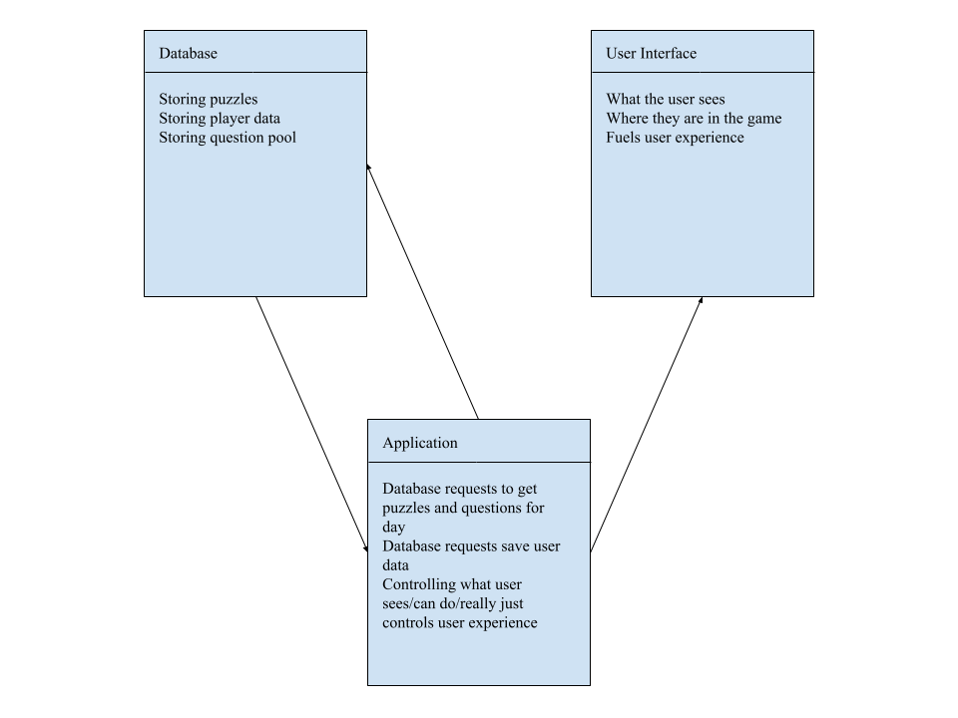

* 1. Development Process and Risk Analysis

We plan to develop this game on a week-by-week basis with the initial focus being on having all the parts working for a single day. Once the game has functionality for a single day, the process from there will involve upscaling to, ideally, a week but we are interested in transitioning the game into an free-play state once the initial week has been completed. The primary risk we have identified with this game would be in the integration of the Maryland Computer Science Curriculum. If the information within the curriculum needs to stay secure then we would need to have a measure in place to make sure that the information cannot be easily accessed by anybody. However, if this information does not need to be secure then there should not be any risks associated with the development of the software.

1. Discussion

By integrating Maryland’s Computer Science curriculum, our software project could impact Computer Science education across the state. Our game could serve as a resource for students when studying for upcoming tests and working on programming assignments. A potential weakness in the game would be select users guessing when it comes to the computer science knowledge checks. If they guess, or randomly select an answer, they will not be receiving the learning benefit implemented into the game. However, we aim to address this issue by restarting the player’s current day if they answer the knowledge check incorrectly.

1. Schedule and Plan

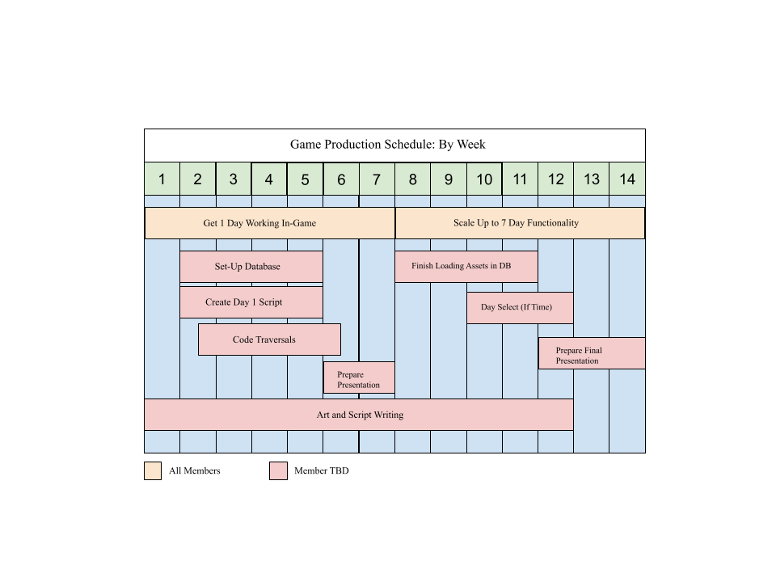

1. Budget

Currently, there is no foreseeable cost when it comes to the development of our game. The only potential cost, that we can currently identify, would be if the Maryland Computer Science question information is locked behind a paywall. Or if the game will have future expansions packs and downloadable content.

1. References

[1] A. Nager and R. D. Atkinson, “The case for improving U.S. Computer Science Education,” *SSRN Electronic Journal*, 2016.

[2] M. -B. Ibáñez, Á. Di-Serio and C. Delgado-Kloos, "Gamification for Engaging Computer Science Students in Learning Activities: A Case Study," in IEEE Transactions on Learning Technologies, vol. 7, no. 3, pp. 291-301, 1 July-Sept. 2014, doi: 10.1109/TLT.2014.2329293.